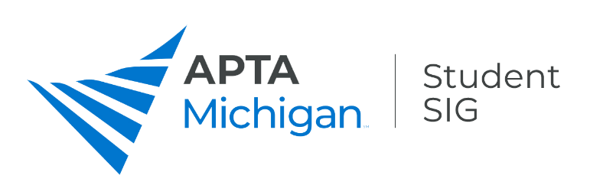
Student Conclave 2022
Friday, April 1
Start | End
7:30 | 8:45 | Breakfast & Registration- Exhibit Hall Open
8:45 | 9:15 | Opening Remarks and Keynote- Edward Mathis, PT, DPT
9:20 | 10:20 | Diagnostics and Rehabilitation Using Musculoskeletal Ultrasound Imaging; a New Frontier for Physical Therapists  Daryl Lawson PT, DSc | Functional Dry Needling: An Evidence-Based Approach  John M. Putnam, PT, DPT, FAAOMPT, Cert. DN, Cert. SMT, Dip. Osteopractic | Demystifying the Alphabet Soup of the Clinical Practice Guideline for Parkinson’s Disease  Jamie Haines, PT, DScPT, NCS  Amy Yorke, PT, PhD, NCS | Resume and Mock Interview
10:20 | 10:30 | Break- Exhibit Hall Open
10:30 | 11:30 | Diagnostics and Rehabilitation Using Musculoskeletal Ultrasound Imaging; a New Frontier for Physical Therapists  Daryl Lawson PT, DSc | Functional Dry Needling: An Evidence-Based Approach  John M. Putnam, PT, DPT, FAAOMPT, Cert. DN, Cert. SMT, Dip. Osteopractic | Demystifying the Alphabet Soup of the Clinical Practice Guideline for Parkinson’s Disease  Jamie Haines, PT, DScPT, NCS  Amy Yorke, PT, PhD, NCS
11:30 | 11:50 | Break- Exhibit Hall Open
11:50 | 12:50 | Lunch – Exhibit Hall Open/Residency and Fellowship Roundup
12:50 | 1:00 | Break- Exhibit Hall Open
1:00 | 2:00 | Get Ready, Get Set, Go Choose Your Job! (Preparing to begin your Physical Therapy Career)  Kevin D. Barclay PT, SCS, ATC, CSCS | A Continuum of Care for Working with the Pediatric Patient  Yvonne D. Jackson, PT, DPT, EdD | Supplemental Oxygen Delivery and Titration- Practical Tips to Prepare You for Clinical Experiences  Nan Pfitzenmaier, PT, DPT, CCS | Resume and Mock Interview
2:00 | 2:10 | Break- Exhibit Hall Open
2:10 | 3:10 | Get Ready, Get Set, Go Choose Your Job! (Preparing to begin your Physical Therapy Career)  Kevin D. Barclay PT, SCS, ATC, CSCS | A Continuum of Care for Working with the Pediatric Patient  Yvonne D. Jackson, PT, DPT, EdD | Supplemental Oxygen Delivery and Titration- Practical Tips to Prepare You for Clinical Experiences  Nan Pfitzenmaier, PT, DPT, CCS
3:10 | 3:25 | Break- Exhibit Hall Open
3:25 | 4:15 | Student Conclave Closing Remarks and Prize Drawings

Student Conclave Sessions- April 1, 2022

Diagnostics and Rehabilitation Using Musculoskeletal Ultrasound Imaging; a New Frontier for Physical Therapists
MSK US imaging is a diagnostic and rehabilitative tool where PT’s can become board certified through the American Institute of Ultrasound in Medicine (AIUM). Clinical evidence and research support using ultrasound as the first diagnostic test for numerous musculoskeletal conditions. The presentation will introduce MSK US imaging of normal and pathological tissue. Rehabilitative MSK US will also be discussed when used for the transverse abdominus muscle for stabilization exercises.

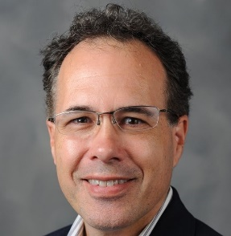
Speaker: Daryl Lawson PT, DSc
Daryl Lawson PT, DSc is an associate professor in the Department of Physical Therapy. After graduating with a degree in physical therapy from the University of Southern California, he practiced for 12 years as a physical therapist in the areas of orthopedics and wound care. His clinical journey included an orthopedic residency at Kaiser Hayward, in Hayward, CA. Prior to joining the faculty at WMU, Daryl was an associate professor in the department of Physical Therapy Education at Elon University. His teaching responsibilities at Elon included orthopedics (lower extremity), electrophysiology, integumentary/wound and a selective course in orthopedics. He was also the faculty advisor for the Elon Pro Bono Clinic and faculty on the Cone Sports Medicine Fellowship program.

Functional Dry Needling: An Evidence-Based Approach
The focus of the presentation is to allow students to discern the difference between acupuncture and dry needling; identify contraindications to dry needling; determine when dry needling would be an effective intervention; understand the risks involved with dry needling; explain the most evidence-based approaches to DN; and explain the physiologic changes that occur with needling.

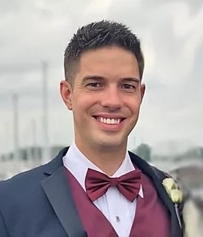
Speaker: John M. Putnam, PT, DPT, FAAOMPT, Cert. DN, Cert. SMT, Dip. Osteopractic
Dr. Putnam is the founder and CEO of Back to You Osteopractic Physical Therapy and Rehabilitation. He graduated with his Bachelor’s from the University of Michigan in 2007 and with his Doctorate in Physical Therapy from the University of Scranton in 2011. He has been the clinic director of several clinics. He was a mentee of Dr. Hamilton Hall, a world renown spinal surgeon and author of "A Consultation with the Back Doctor." He became certified in Dry Needling in 2016 and has performed over 6,000 treatments, completed advanced training, and assisted in teaching courses on the technique. In 2017 he became certified in Spinal Manipulation Therapy and graduated with his first Diploma in Osteopractic, becoming one of 200 Osteopractors in the entire world. The diploma includes training in body tempering, cupping, instrument-assisted soft-tissue mobilization, differential diagnosis, dry needling, extremity manipulation, and spinal manipulation. In 2018 he founded Back to You Rehab, PLLC and went through American Academy of Manipulative Therapy’s 1,000 hour fellowship program. This is the largest fellowship in the U.S. and conducts some of the nation’s most robust research. He graduated with his second Diploma in Osteopractic. He conducted research on shoulder pain, TMJ dysfunction, body tempering, and the opioid epidemic. In 2019 he became a consultant for SI-bone, educating physicians, therapists, and staff on the diagnosis and treatment of sacroiliitis pain. In 2019, Dr. Putnam graduated from his fellowship and became a Fellow of the American Academy of Orthopedic Manual Physical Therapy, a credential earned by only 1-2% of all Physical Therapists. Both the fellowship and Osteopractic credentials have been clinically proven to improve patient outcomes. In 2019, "Back to You" was awarded the national clinic of the year by AAMT. He is a clinical instructor for Wayne State University, Baker College, Xavier University, Washtenaw Community College, and for fellows in training.

Demystifying the Alphabet Soup of the Clinical Practice Guideline for Parkinson’s Disease
You wanna talk PANDEMIC? Once a rare disease, Parkinson’s Disease is now considered the fastest growing of the neurological disorders based on age standardized rates of prevalence, disability and deaths. It is expected that worldwide the number of people with PD will exceed 12 million by 2040.^{1,2} No doubt you will eventually encounter a person seeking your help for PD. In 2021, a clinical practice guideline on Parkinson disease was developed by an American Physical Therapy Association (APTA) based on systematic reviews of current scientific and clinical information and accepted approaches for management of Parkinson disease.³ So, what does this mean for you as a student? Let’s decipher the recommendations together so you can confidently provide best-practice interventions for those with PD.
Speakers:
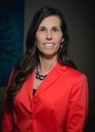
Dr. Jamie Haines, PT, DScPT, ABPTS Board Certified Neurologic Clinical Specialist
Dr. Jamie Haines is an Assistant Professor in the Physical Therapy Department at Central Michigan University. She received her Master of Science in Physical Therapy from Grand Valley State University and completed her DScPT from Oakland University. She is a Board Certified Neurologic Clinical Specialist through the American Board of Physical Therapy Specialties, certified in 2005 and recertified in 2015 and is a Parkinson’s Foundation Physical Therapy Faculty Scholar. Dr. Haines has been recognized for her teaching by receiving an Excellence in Teaching Award in 2020. Dr. Haines oversees physical therapy services at Hands for Health, a student led pro bono clinic at CMU. In addition, she supervises students in the program’s weekly exercise and dance class for people with Parkinson’s Disease and is the Central Michigan Area Parkinson’s Support Group facilitator. Dr. Haines’ research interests include Parkinson’s Disease, use of assistive technology to promote recovery principles, and teaching and learning principles in DPT education. She is a member of the American Physical Therapy Association including Academies of Neurologic PT, Acute Care and Education.
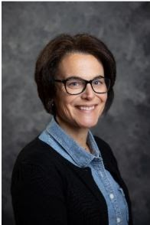
Dr. Amy Yorke, PT, PhD, ABPTS Board Certified Neurologic Clinical Specialist
Dr. Amy Yorke is an Associate Professor in the Physical Therapy Department at the University of Michigan-Flint. She received her B.S. in Health Science and Master's Degree in Physical Therapy from the University of Michigan-Flint and her PhD in Interdisciplinary Health Sciences from Western Michigan University. She is Board Certified in Neurologic Physical Therapy (ABPTS), a and a Parkinson's Foundation Physical Therapy Faculty Scholar. Dr. Yorke has been recognized for her teaching by receiving the Lois Matz Rosen Junior Faculty Excellence in Teaching Award, and has taught at both the professional and post-professional level. Dr. Yorke is a member of the American Physical Therapy Association and currently serves as the co-chair for the Knowledge Translation Vestibular Hypofunction task force for the Academy of Neurologic Physical Therapy. She also oversees the physical therapy services at PT Heart, a student led pro bono clinic at UM-Flint. As the team lead of the Integrating KNOWledge Translation (iKNOW) lab, Dr. Yorke research interests are in translating evidence based practices to clinical, community, and academic settings in order to improve patient outcomes. In addition, Dr. Yorke is interested in further understanding interprofessional collaborative practice in both education and in the clinic.

Get Ready, Get Set, Go Choose Your Job! (Preparing to begin your Physical Therapy Career)
This course is designed to provide information for graduating Physical therapy students preparing to entire the workforce, and to help them choose their best fit. Information presented will include what many physical therapy companies look for when reviewing applicants including resume review and interviewing, discussion on how to compare job offers including compensation/benefits, growth opportunities, mentoring and culture as well as comparison of treatment and reimbursement models most commonly used. There will be time available for general discussion with a physical therapy practice CEO to answer any student questions.

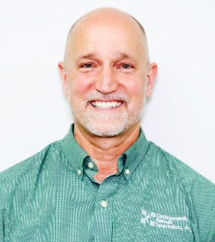
Speaker: Kevin D. Barclay PT, SCS, ATC, CSCS
Kevin is the President and CEO for Orthopaedic Rehab Specialists, PC. ( ORS ). He is a 1988 graduate of the State University of NY at Buffalo where he double majored in Physical Therapy and Exercise Science.
He began his career at ORS in 1991 as a staff physical therapist and became the Director of Sports Medicine in 1996 after receiving his Athletic Training Certification.
In 2001 Kevin earned his Board Certification in Sports Physical Therapy from the APTA and in 2016 became a Certified Strength and Conditioning Specialists through the National Strength and Conditioning Association. He has been an owner of ORS since 2002 and became its CEO in 2020.A

Continuum of Care for Working with the Pediatric Patient
The presentation will offer some tips for working with the pediatric population in any setting including but not limited to: NICU, Inpatient, Early Intervention, Schools, Outpatient, Home Care, and Telehealth. This course is ideal for all students including students who may not have an interest in working with the pediatric population but my still encounter a pediatric patient.

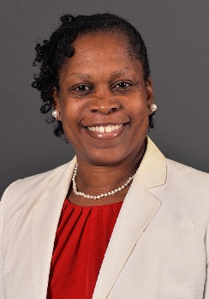
Speaker: Yvonne D. Jackson, PT, DPT, EdD
Dr. Jackson has been practicing Physical Therapy Since 1991. She received her Bachelor of Science degree in Physical therapy from Wayne State University in 1990. She also completed her Master of Arts degree with a focus on Sports Administration and Educational Specialists Degree in Special Education Administration at Wayne State University in 1993 and 2008 respectively. She earned a Doctor of Education with a focus on Teacher Leadership from Walden University in 2016 and earned Doctor of Physical Therapy at Rocky Mountain University of Health Professions with a focus on Pediatric Science in 2019. Yvonne started her career at the Rehabilitation Institute of Michigan from 1991-1994. She then went on to work at the Detroit Public Schools from 1994-2013. She joined Baker College’s Physical Therapy Assistant Program in 2012 as an adjunct and became the Academic Coordinator from 2013-2018. She is currently working at Western Michigan. University in the developing Doctor of Physical Therapy Program as an Assistant Professor and providing Telehealth Services through EBS Healthcare/The Steppingstones Group to Pediatric Patients throughout the state. Dr. Jackson is currently a member of the APTA-MI Legislative Committee, Secretary of the APTA-MI Pediatric SIG, and the APTA Pediatrics-Michigan State Pediatric Advocacy Liaison.

Supplemental Oxygen Delivery and Titration- Practical Tips to Prepare You for Clinical Experiences
This course is designed for student physical therapists and physical therapist assistant students that will be participating in the care of patients receiving supplemental oxygen. It is meant to provide an overview of various supplemental oxygen delivery devices commonly seen in both general acute care practice and outpatient practice. In this course we will discuss practical management of these devices as well as the titration of oxygen during physical therapy interventions for a variety of conditions. The course provides a review of the difference between ventilation and respiration, describes supplemental oxygen flow in liters per minute in relation to fraction of inspired oxygen (FiO2), and will help prepare you to impress your clinical instructors during your upcoming clinical experiences.
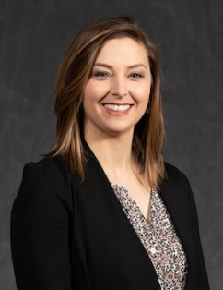
Speakr: Nan Pfitzenmaier, PT, DPT, CCS
Nan Pfitzenmaier, PT, DPT, CCS has worked as a board-certified clinical specialist in cardiovascular and pulmonary physical therapy since 2016. She currently practices at Henry Ford Hospital in Detroit in the Medical and Cardiothoracic Intensive Care Units. She serves as the cardiopulmonary practice mentor for the Henry Ford Hospital (HFH) Acute Care Physical Therapy Residency program and as the Rehabilitation Research Coordinator for the HFH rehab department. Nan is an Assistant Professor in the DPT program at Wayne State University and serves as the faculty liaison for the Diabetes Education and Wellness (DEW) pro bono clinic. Nan’s research focuses on acute care physical therapy and critical care rehabilitation and she has presented on topics related to her specialty practice, research, and clinical mentoring at APTA-MI’s annual conferences and the APTA's Combined Sections Meetings.

